1.Explain the advantages of Natural Queries in PowerBi with an example?

## A: Benefit 1 - Guided NLQ is a unique self-service BI experience-

## After selecting a dataset, you’re presented with a search box you can type in, but it’s not blank. Guided NLQ provides a list of options for possible questions, then guides you through each step in formulating the query. You can choose your own path through the question by typing what you want to ask, using your mouse to choose an option, or both.

## Benefit 2 - Every question is understood by Guided NLQ-

## Traditional search-based NLQ solutions are harder to set up because they’re focused on fixing the wrong problem: semantics (language used in a question), rather than analytics.

## With Guided NLQ, there is no need to set up synonyms and word dictionaries, or continuously train the solution to understand your users’ intent, because using the Yellowfin metadata layer bypasses this problem altogether.

## Benefit 3 - Guided NLQ makes it simple to ask complex questions-

## Guided NLQ approaches question complexity differently by implementing thousands of comprehensively modelled question types and sequences, which effectively enables anyone to ask questions of their data, and to deliver answers as best practice visualizations or tabular reports for every possible question combination you can think.

## Benefit 4 - Guided NLQ is integrated throughout-

## With Guided NLQ, you can ask an ad-hoc question and immediately drop that into other content that you're working on, or share it with other colleagues. If you were working on your own content already (such as Dashboards, Stories, etc.), you can access Guided NLQ from those builders as well, and drop the answers into that with a seamless workflow.

## Benefit 5 - It's easy to embed Guided NLQ into your applications-

## In enterprises, data analysts are usually the ones engaging in self-service analytics because it has a big learning curve, and non-technical business users don't have the necessary skills to perform it themselves, nor the time to build those skills. Guided NLQ gives these business users through the enterprise the ability to self-serve BI without having to rely on scarce data experts or analysts every time they want to explore data.

## 2.Explain Web Front End(WFE) cluster from Power BI Service Architecture?

The architecture of Power BI Service is divided into two sections:

* Front End cluster
* Back End cluster

**Front End Cluster**

Clients and the back end are connected by the front end, commonly known as the web front-end cluster. The front-end services handle the initial connection and Azure Active Directory client authentication. User IDs are kept in the Azure Active Directory. After authentication, user requests are routed through Azure Traffic Manager to the closest data center. The Azure Content Delivery Network (CDN) makes static Power BI content and files available to users when a client or user has been authorized.

3.Explain Back End cluster from Power BI Service Architecture?

The architecture of Power BI Service is divided into two sections:

* Front End cluster
* Back End cluster

**Back End Cluster**

Visualizations, datasets, storage, reports, data connections, data updating, and other Power BI interactions are handled by the Power BI services on the back end. A web client can only directly interface with Azure API Management and Gateway Role on the backend. These two parts are in charge of routing, load balancing, authentication, and authorization.

4.What ASP.NET component does in Power BI Service Architecture?

* Power Query (for data mash-up and transformation)
* Power BI Desktop (a companion development tool)
* Power BI Mobile (for Android, iOS, Windows phones)
* Power Pivot (for in-memory tabular data modeling)
* Power View (for viewing data visualizations)
* Power Map (for visualizing 3D geo-spatial data)
* Power Q&A (for natural language Q&A

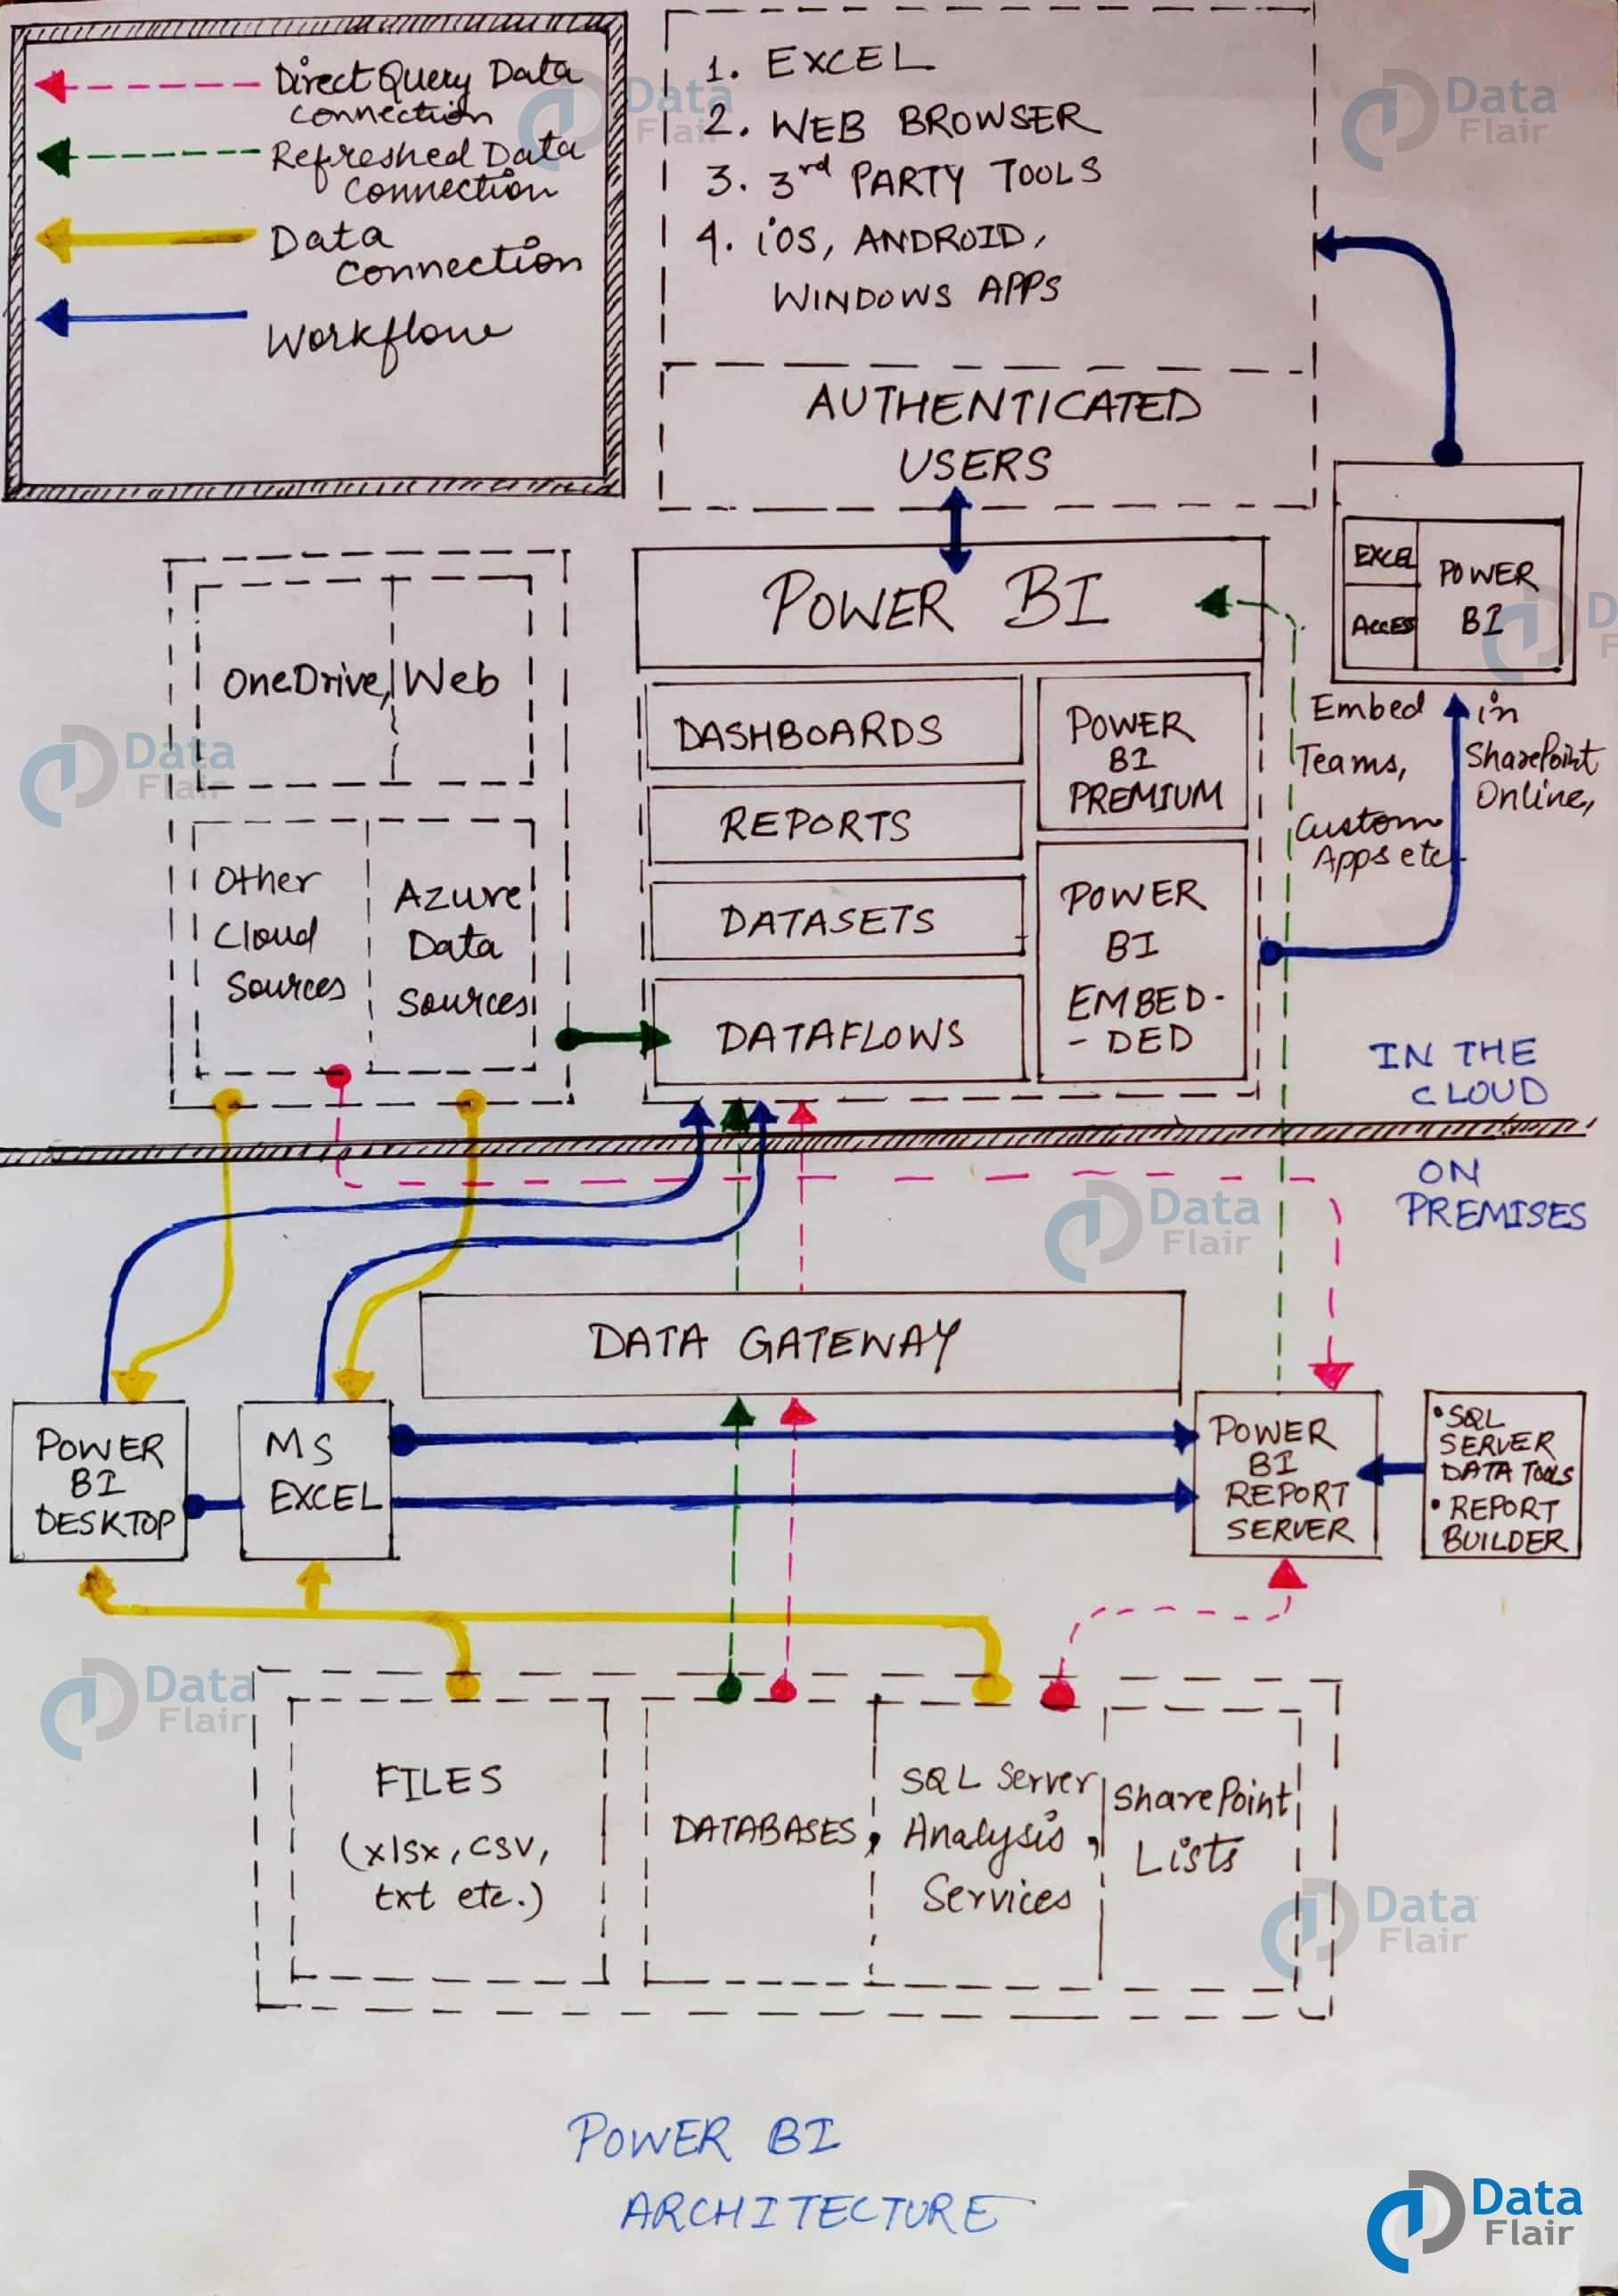

## 5.Compare Microsoft Excel and PowerBi Desktop on the following features:

## a) Data import-

## Excel struggles to handle a large amount of data and often says “Not Responding” error with a large quantity of data.

## Power BI can handle large amounts of data with the Power Pivot engine model. More importantly, it does not restrict to any specific versions of Excel or Office 365.

## b) Data transformation-

## Excel can get data from everywhere with Power Query.

## Power BI also has Power Query; it can fetch data from everywhere

## c)Modeling-

## Who does not know Excel? Excel is the universal language spoken in almost all the offices worldwide. Because Excel has been around for a long time, most users find it easy to learn.

## Power BI is not that easy. It requires considerable knowledge of Power Query and Power Pivot DAX formulas and techniques to use it.

## d)Reporting-

## Excel has only a few built-in charts, and we need to work with only those charts to build dashboards.

## Power BI has a wide variety of visualizations. We can import many other visuals from the marketplace besides available built-in charts.

## e) Server Deployment-

## Excel Server is a DIY tool for building an excel-based information system. It integrates MS Excel and MS SQL Server.

## Power BI Report Server can be deployed in Azure VMs (hosted cloud) if licensed through Power BI Premium or SQL Server Enterprise with Software Assurance.

## f) Convert Models-

## Excel

* Start by selecting any cell within the data that you want to add to the model.
* Use one of these approaches to add your data:
* Click Power Pivot > Add to Data Model.
* Click Insert > PivotTable, and then check Add this data to the Data Model in the Create PivotTable dialog box.

## Power BI

* The following describe about data models, and also describe Direct Query in detail.
* [Aggregations in Power BI Desktop](https://learn.microsoft.com/en-us/power-bi/enterprise/aggregations-auto)
* [Composite models in Power BI Desktop](https://learn.microsoft.com/en-us/power-bi/transform-model/desktop-composite-models)
* [Storage Mode in Power BI Desktop](https://learn.microsoft.com/en-us/power-bi/transform-model/desktop-storage-mode)
* [Many-to-many relationships in Power BI Desktop](https://learn.microsoft.com/en-us/power-bi/transform-model/desktop-many-to-many-relationships)
* Direct Query articles:
* [Using Direct Query in Power BI](https://learn.microsoft.com/en-us/power-bi/connect-data/desktop-directquery-about)
* [Data sources supported by Direct Query in Power BI](https://learn.microsoft.com/en-us/power-bi/connect-data/power-bi-data-sources)

g) **Cost-**

* Since we already have **Excel**, we need to spend additional money to procure this and build dashboards.
* **Power BI** Desktop is free to download and use for personal use, but it takes $10 per month per user to share reports with others.

6.List 20 data sources supported by Power Bi desktop.

A:

* Excel
* Text/CSV
* XML
* JSON
* Oracle Database
* IBM DB2 Database
* MySQL Database
* PostgreSQL Database
* Sybase Database
* Teradata Database
* SAP HANA Database
* SAP Business Warehouse server
* Amazon Redshift
* Impala
* Google Big Query (Beta)
* Azure SQL Database
* Salesforce Reports
* Google Analytics
* Facebook
* GitHub